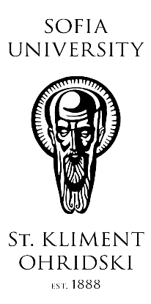
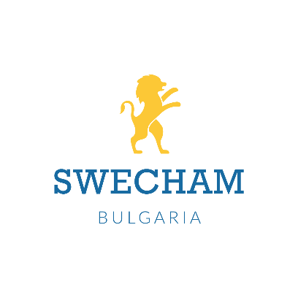 | 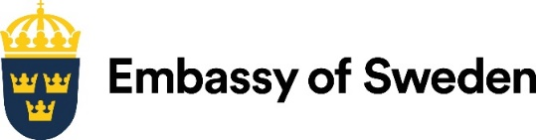
PROFESSIONAL SKILLS IN DEMAND

Meeting of the Nordic and Nordic-related business in Bulgaria
with the participation of the Scandinavian Studies Programme
at Sofia University “St. Kliment Ohridski”

26 November 2019
16.30 hrs.

Hall 1, Sofia University “St. Kliment Ohridski”
15 Tsar Osvoboditel Blvd., entry from the courtyard (next to the tunnel)

Оrganised by

Scandinavian Studies Programme at Sofia University “St. Kliment Ohridski”
Embassy of Finland within Finland’s Presidency of the Council of the EU,
July-December 2019
Norwegian-Bulgarian Business Group

in partnership with

Embassy of Denmark
Embassy of Sweden, Stockholm-based
Norwegian Honorary Consulate General
Swedish Bulgarian Chamber of Commerce

AGENDA

Language: English, no translation is provided

Moderators: Nadezhda Mihaylova, Scandinavian Studies Programme, Sofia University
Miriana Alexandrova, Executive Director of the Norwegian-Bulgarian
Business Group

16:30 – 16:35 Welcome speech by Prof. Madeleine Danova,
Dean of the Faculty of Classical and Modern Philology at Sofia University

16:35 – 16:45 Opening speech by Finnish Ambassador to Bulgaria H.E. Päivi Blinnikka
“The cooperation between business and education – Finland’s example”

16:45 – 16:50 Welcome speech by
Swedish Ambassador to Bulgaria H.E. Louise Bergholm

16:50 – 16:55 Welcome speech by
Danish Ambassador to Bulgaria H.E. Søren Jacobsen

16:55 – 17:00 Welcome speech by
Honorary Consul General of Norway Ms. Venceslava Yanchovska

17:00 – 17:15 “The curriculum of the Scandinavian Studies
Programme at Sofia University”
Ivan Tenev, Scandinavian Studies Programme

17:15 – 17:30 “Professional skills and talents – the employer’s perspective”
Bistra Papazova, Deputy Chair of the Norwegian-Bulgarian Business Group,
CEO Cobuilder International

17:30 – 18:30 Plenary discussion based on the discussion points listed below

The demand for talents with high-level professional skills, both hard and soft, has been soaring in the last decade. At the same time, the focus of university training has shifted to a more practically oriented and market-responsive approach, while keeping its theoretical core intact.

The proposed meeting aims at identifying the needs of the Nordic and Nordic-related businesses operating in Bulgaria for talents with specific skills and the capacity of the Scandinavian Studies Programme to answer those needs. The meeting will set the framework for closer long-term and country-specific cooperation between Sofia University and Nordic businesses in the form of regular problem-oriented dialogue.

The skills in question include but are not limited to:

- Language skills – Nordic languages;

- Cognitive skills – information processing skills; critical analysis and critical reasoning skills; efficient comprehension of written and oral discourse in a variety of contexts, etc.;

- Business communication skills in an international and a Nordic-Bulgarian environment – business etiquette; business ethics; efficient written, oral and electronic communication;

- Mastering the challenges of intercultural communication and intercultural understanding, the concept of CSR in a Nordic perspective;

- Productivity skills – time management, task management and prioritisation in a Nordic-Bulgarian setting; balance between personal and professional life, etc.;

- People skills and soft skills.

Note that specific technical skills, e.g. engineering and IT skills, fall outside the scope of the meeting.
The meeting is seen as a platform for discussion both between the Nordic and Nordic-related companies internally and between the Nordic businesses and the Scandinavian Studies Programme.
Expected outcome of the meeting

- Identify the needs of Nordic and Nordic-related businesses in Bulgaria regarding the skills listed above;
- Get feedback from the businesses and identify ways in which the Scandinavian Studies can respond, e.g. by adapting existing curriculum or designing new, more targeted, training courses; negotiation of student traineeships and internships at Nordic businesses, etc.;
- Identify modes of bilateral and multilateral cooperation between the Nordic and Nordic-related businesses in Bulgaria, Nordic-Bulgarian business groups and chambers of commerce, Nordic missions to Bulgaria and the Scandinavian Studies at Sofia University.

Ultimately, the meeting will be of practical relevance for the Nordic businesses in Bulgaria, will strengthen the cooperation between the stakeholders and will contribute to establishing the Scandinavian Studies Programme as a functional link between knowledge and competence building, students and business.

Contact persons

Ivan Tenev, Sofia University
ivan.tenev@gmail.com

Lydia Draganova, Embassy of Finland
lydia.draganova@formin.fi

Miriana Alexandrova, Norwegian-Bulgarian Business Group
contact@nbbg.eu

Tsvetelina Aronova, Embassy of Denmark
tsvaro@um.dk

Maria Lakova, Embassy of Sweden, Stockholm-based
maria.lakova@consulateofsweden.eu

